Ideation Phase

Brainstorm & Idea Prioritization

|  |  |
| --- | --- |
| Date | 29 APRIL 2023 |
| Team ID |  |
| Project Name | The Future of Work: Data Analysis of Glassdoor Jobs |
| Maximum Marks | 4 Marks |

# Step-1: Team Gathering, Collaboration and Select the Problem Statement.

# 

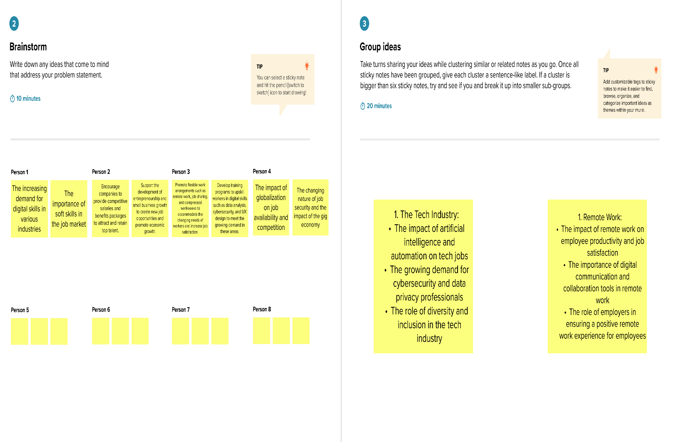**Step-2: Brainstorm, Idea Listing and Grouping**

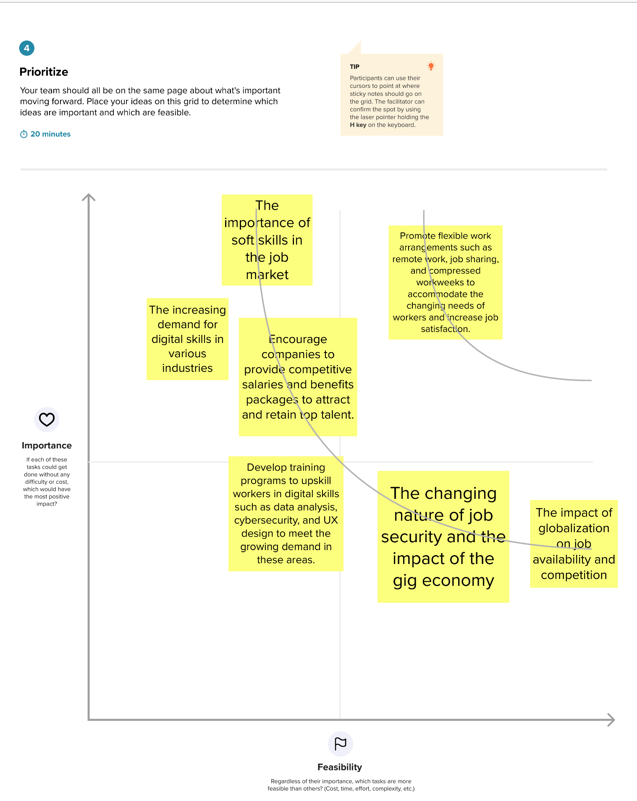**Step-3: Idea Prioritization:**